COLD ASHBY VILLAGE HALL
Main Street, Cold Ashby NN6 6EL
Charity number 1024816
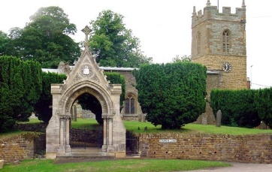
Committee Meeting Minutes

Tuesday 21st August, 2018: 7.30 p.m.

Minutes

- Minutes of meeting on 22nd May 2018 were approved
- Matters arising: none
- Apologies for absence: Bob Gammage, Rod Bailey, Alex Taylor, Sharon Taylor: not present. Present: BB (chair), LG, KG, RM, GJ, CS.
- Chairman’s report: covered by agenda items
- Finance:
- Monthly accounts May-August: accounts were accepted and chairman confirmed totals tallied with bank. Concerns over high levels of water bills. Sec/chair to monitor/investigate.
- Windfarm bid: secretary to proceed with bid based on electrical spec and building spec. First quote had been received.

- Activities and usage update:
- Luncheon club: luncheon club advised to contact caterer for addition support with clearing away.
- Table tennis – membership extension: agreed to maintain village only membership for the time being and to push for additional members.

AOB: A list of minor works was presented by CS. Members are advised to report faults as soon as they come to attention, given the three-month gap between meetings.

Next meeting is combined committee/AGM on 20th November. Meeting concluded 8.00 p.m.

G Jones, Secretary August 2018

